Problem Analysis
Problem Analysis:
The project investigates how free primary healthcare affects healthcare utilization in a peri-urban region of Bamako, Mali. The core objective is to determine whether removing user fees leads to increased healthcare-seeking behavior among mothers for their children. analyzes how the provision of free healthcare affects when and where mothers seek medical care for their children
The study relies on:
- Randomized Controlled Trial (RCT): Households are divided into intervention groups (free primary care, health worker visits, and a control group).
- Machine Learning Models: Logistic Regression, Decision Trees, XGBoost and SVM are used for prediction.
- Causal Inference Methods: Difference-in-Differences (DiD) and Propensity Score Matching (PSM) estimate the impact of free healthcare.
- Visualization & Deployment: Findings will be presented via interactive dashboards.
Solution Approach:
- Data Preparation
  - Load the dataset (DeanSautmann-WBER-HealthOutcomesMali.csv).
  - Handle missing values and normalize data.
  - Structure intervention groups and household characteristics.
- Exploratory Data Analysis (EDA):
  - Analyze healthcare utilization trends across intervention groups.
  - Identify correlations between household demographics and healthcare-seeking behavior.
- Predictive Modeling:
  - Train models (Logistic Regression, Decision Trees, XGBoost,SVM) to predict whether a mother seeks medical care based on policy interventions.
  - Evaluate models using accuracy, precision, recall, and AUC scores.
- Causal Inference Analysis:
  - Use Difference-in-Differences (DiD) to compare healthcare utilization before and after the intervention.
  - Apply Propensity Score Matching (PSM) to control for selection bias.
- Visualization & Insights:
  - Develop dashboards showing healthcare utilization trends.
  - Provide policy recommendations based on model findings.
- Deployment:
  - Deploy models and findings as a Flask/Django-based web application.
  - Allow policymakers to input demographic and policy parameters for predictions.
Dataset Overview:
- Total Records: 1,652 entries
- Total Columns: 243
- Data Types:
  - Float64: 196 columns
  - Int64: 39 columns
  - Object (String): 8 columns
Key Observations:
- The dataset has 243 features, indicating a rich set of variables.
- Some important columns:
  - FPrimary, Person_ID, Mother_ID, compound – Identifiers for families and individuals.
  - TrtOrder, TrtOrder2013 – Treatment assignment (possibly intervention groups).
  - Ill_days_total – Number of days the child was ill.
  - Blood_Stool_last_week, MUAC_danger – Health-related indicators.
  - Months_breastfeeding_correct, ORT_ingr_correct – Maternal and child health indicators.
  - tag_HH, tag_C, tag_M – Possibly categorical labels.
Missing Values Analysis:
- Data set have 243 columns, a 30% threshold may remove a smaller proportion of columns. .
- 136 columns have more than 30% missing values, with some being completely empty (100% missing).
- Examples of columns with 100% missing values:
  - Previous_water_source_other
  - DTCoq_number_sr_
- Some health-related and water hygiene variables have 30-50% missing values.
Action Plan:
- Drop columns with 100% missing values – Since they provide no useful data.
- Drop columns having more than 30% missing values.
- Replace NaN values in the column -median used fro Numerical values,mode used for Categorical values.
- Drop column ‘consent’ ,all values in this column is 1.
- Impute missing values for essential health-related metrics using:
  - Mean/median for numerical variables.
  - Mode or forward-fill for categorical variables.
- Identify key intervention and healthcare utilization features.
Key Findings from Intervention and Healthcare Metrics:
- Treatment Group Assignment (TrtOrder, TrtOrder2013):
  - Values range from 1 to 4, likely representing different intervention groups (e.g., free primary care, health worker visits, control).
  - Distribution is fairly balanced across groups.
- Healthcare Utilization Metrics:
  - Illness Days (Ill_days_total):
    - Mean: 0.45 days, Max: 7 days → Most children had low illness days.
  - Malnutrition Indicator (MUAC_danger):
    - 1.6% of children fall into malnutrition danger (MUAC = 1).
  - Recent Symptoms (Blood_Stool_last_week):
    - Only 0.8% reported blood in stool.
  - Breastfeeding Practices (Months_breastfeeding_correct):
    - 58% of mothers followed recommended breastfeeding duration.
  - Oral Rehydration Therapy (ORT_ingr_correct):
    - 40% correctly used ORT ingredients for child treatment.
Next Steps:
- Compare healthcare utilization across intervention groups.
- Compare Total Illdays(healthcare utilization) and Free care check up.
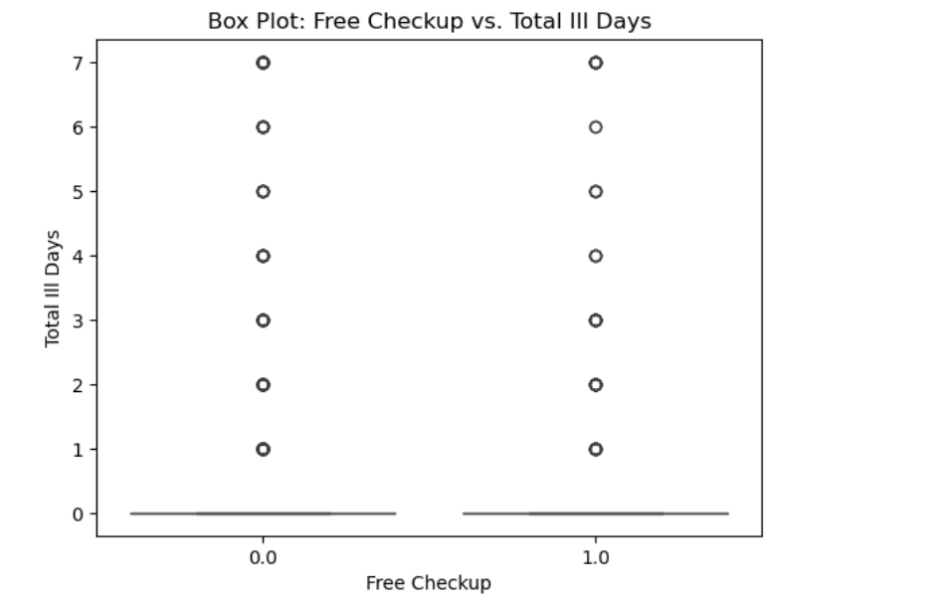

Key Insights
- There is no clear pattern showing whether a free checkup reduces ill days.
- Both groups (those with and without free checkups) show similar distributions in terms of ill days.
- A deeper analysis (e.g., using a box plot or statistical tests) is needed to determine if free checkups have a significant impact on reducing illness days.

- Check statistical significance of differences (e.g., ANOVA, Chi-square test).
- Train predictive models to assess if intervention type influences medical care-seeking behavior.
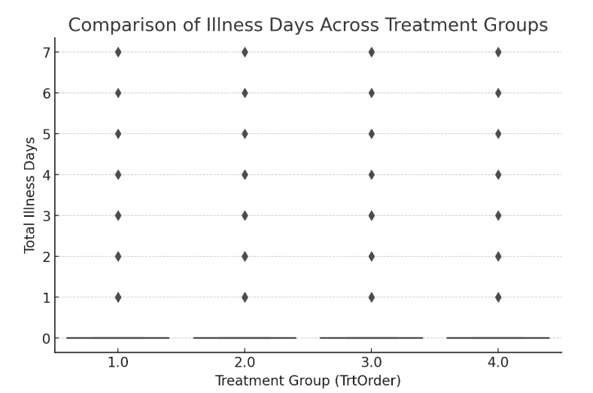
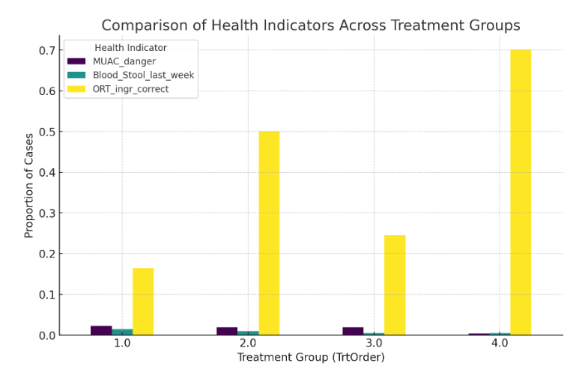

Insights from Intervention Group Comparison:
- Illness Days vs. Treatment Groups:
  - There is no significant difference in illness days across treatment groups.
  - Most values are concentrated around 0 illness days, with a few outliers experiencing up to 7 days of illness.
- Health Indicators Across Treatment Groups:
  - Malnutrition (MUAC_danger) is consistently low across all groups (~1-2%).
  - Blood in Stool (Blood_Stool_last_week) remains very rare (~0.8% across groups).
  - Correct ORT Usage (ORT_ingr_correct) shows higher adoption in some treatment groups, indicating potential intervention impact.

- Analysis of Free Care Impact on Healthcare Utilization
3.1. CSCOM Utilization (Community Health Center)
- No Free Care: 1.98%
- With Free Care: 3.40% (increase)
Free care increases visits to CSCOMs.
- Likely because patients prefer low-cost or government-supported health centers when free care is available.

3.2 . Hospital Utilization
- No Free Care: 0.09%
- With Free Care: 0.17% (increase)
Free care increases hospital visits.
- Patients may be accessing higher-level care more frequently when cost is not a barrier.

3.3 Private Clinic Utilization
- No Free Care: 0.47%
- With Free Care: 0.17% (decrease)
Free care reduces private clinic visits.
- Since private clinics are usually expensive, patients may opt for government-subsidized care instead.

3.4 Traditional Medicine Utilization
- No Free Care: 3.01%
- With Free Care: 2.38% (decrease)
Free care reduces reliance on traditional medicine.
- Patients may be shifting from traditional healers to formal medical care when cost is not a concern.

3.5 Pharmacy Utilization
- No Free Care: 3.20%
- With Free Care: 0.85% (sharp decrease)
Free care reduces pharmacy visits.
- Likely because medicines are covered under free care, reducing the need for out-of-pocket drug purchases.

3.6. Pharmacy Parterre Utilization
- No Free Care: 6.69%
- With Free Care: 5.94% (decrease)
Free care reduces Pharmacy Parterre visits, though less dramatically than regular pharmacies.
- Some patients may still buy medications outside the free care system.

Overall Insights
Free care shifts patient behavior significantly:
- More visits to public health facilities (CSCOMs, hospitals).
- Less reliance on private clinics, traditional medicine, and pharmacies.
- Pharmacy visits drop the most, indicating a strong impact on out-of-pocket drug spending.

- fbf
Next Steps:
- Statistical Significance Testing – Check if the observed differences are meaningful.
- Predictive Modeling – Train models to predict healthcare-seeking behavior based on interventions.
Statistical Significance Test Results:
- ANOVA for Illness Days Across Treatment Groups:
  - F-statistic: 1.28
  - p-value: 0.278
  - Since the p-value is greater than 0.05, we fail to reject the null hypothesis, meaning no significant difference in illness days across treatment groups.

- ANOVA for Blood_Stool_days_total Across Treatment Groups:
  - F-statistic: 0.84
  - P-value: 0.4742
  - No significant difference in blood stool days across treatment groups.
- ANOVA for Blood Stool days total across free care checkup:
  - F-statistic: 0.84
  - P-value: 0.4742
  - No significant difference in blood stooldays across across free check up.
[104]:

- ANOVA for Illness Days Across Treatment Groups:

  - F-statistic: 1.28
  - p-value: 0.278
  - Since the p-value is greater than 0.05, we fail to reject the null hypothesis, meaning no significant difference in illness days across treatment groups.

Next Steps:
- Train Machine Learning Models to predict healthcare-seeking behavior based on interventions.
- Use Causal Inference Methods (DiD, PSM) to estimate the direct impact of free healthcare.
start with predictive modeling, where we train machine learning models to predict whether a mother seeks medical care based on the intervention type.
Steps:
- Feature Selection – Choose relevant predictors such as intervention type, illness days, and health indicators.
- Target Variable – Define the outcome variable (e.g., whether healthcare was sought).Here the outcome variable is free_care_check_.The dataset is imbalanced.So balancing the dataset using SMOT algorithm.
- Train ML Models – Logistic Regression, Decision Trees, XGBoost with hyperparameter tuning and SVM.
- Evaluate Performance – Accuracy, Precision, Recall.
check the dataset for an appropriate target variable (e.g., healthcare utilization).

Potential Target Variables:
- free_care_check_ – Indicates whether free healthcare was utilized.
Since we aim to predict healthcare-seeking behavior, use free_care_check_ as the target variable.
Next Steps:
- Preprocess data: Handle missing values and encode categorical variables.
- Split dataset into training and testing sets.
- Train machine learning models.
Data Preprocessing Complete:
- 848 training samples and 212 test samples.
- 5 features selected: TrtOrder, Ill_days_total, MUAC_danger, Blood_Stool_last_week, ORT_ingr_correct.
- Missing values handled using median imputation.
- Features standardized using StandardScaler.
Next Steps:
- Train Logistic Regression, Decision Trees, and XGBoost.
- Evaluate model performance using accuracy, precision, recall.
Model Performance Results:
Model | Accuracy | Precision | Recall
Logistic Regression | 78.54% | 65.49% | 90.32%
Decision Tree | 79.15% | 65.89% | 91.93%
Decision Tree* | 79.15% | 65.89% | 91.93%
XGBoost | 78% | 64.88% | 87.90%
XGBoost* | 78% | 65.29% | 89.51%
SVM | 78% | 65.66% | 87%
*- The models were trained using hyperparameter tuning
Here are some key observations based on the model performance metrics:
- Decision Tree Performs Best Overall
  - The Decision Tree model has the highest accuracy (79.15%), along with the highest recall (91.93%) among all models.
  - Its precision (65.89%) is slightly better than Logistic Regression but very close.
- Trade-off Between Precision and Recall
  - Logistic Regression has a relatively high recall (90.32%), meaning it captures more positive cases, but its precision (65.49%) is slightly lower.
  - XGBoost initially had a lower recall (87.90%) but improved with tuning (XGBoost), reaching 89.51%.
  - SVM has the lowest recall (87%), suggesting it misses more positive cases compared to the others.
- XGBoost Shows Improvement with Tuning
  - Before tuning, XGBoost had 64.88% precision and 87.90% recall.
  - After tuning (XGBoost), it improved precision to 65.29% and recall to 89.51%, making it a more balanced model.
- SVM Has the Lowest Recall
  - With 87% recall, SVM is the least effective at identifying positive cases, which might not be ideal if recall is a priority.
Conclusion:
- The main goal is identifying as many positives as possible, Decision Tree is the best choice.
- If a balance between precision and recall is needed, XGBoost (after tuning) might be a better option.
- Logistic Regression and SVM have relatively lower recall and precision compared to the others.

